Mehmet Izol

Doctor Tai Cleveland

COMP 3324

Installing Linux

4/7/2023

Installing Linux

# I installed Ubuntu and formatted all other files on my laptop, Azamat Salamatov helped me with this lab

# Initially, we downloaded VMWare, then I did not work. When we changed some settings from BIOS, It began to work.

# But then we decided to delete Windows and Download Linux.

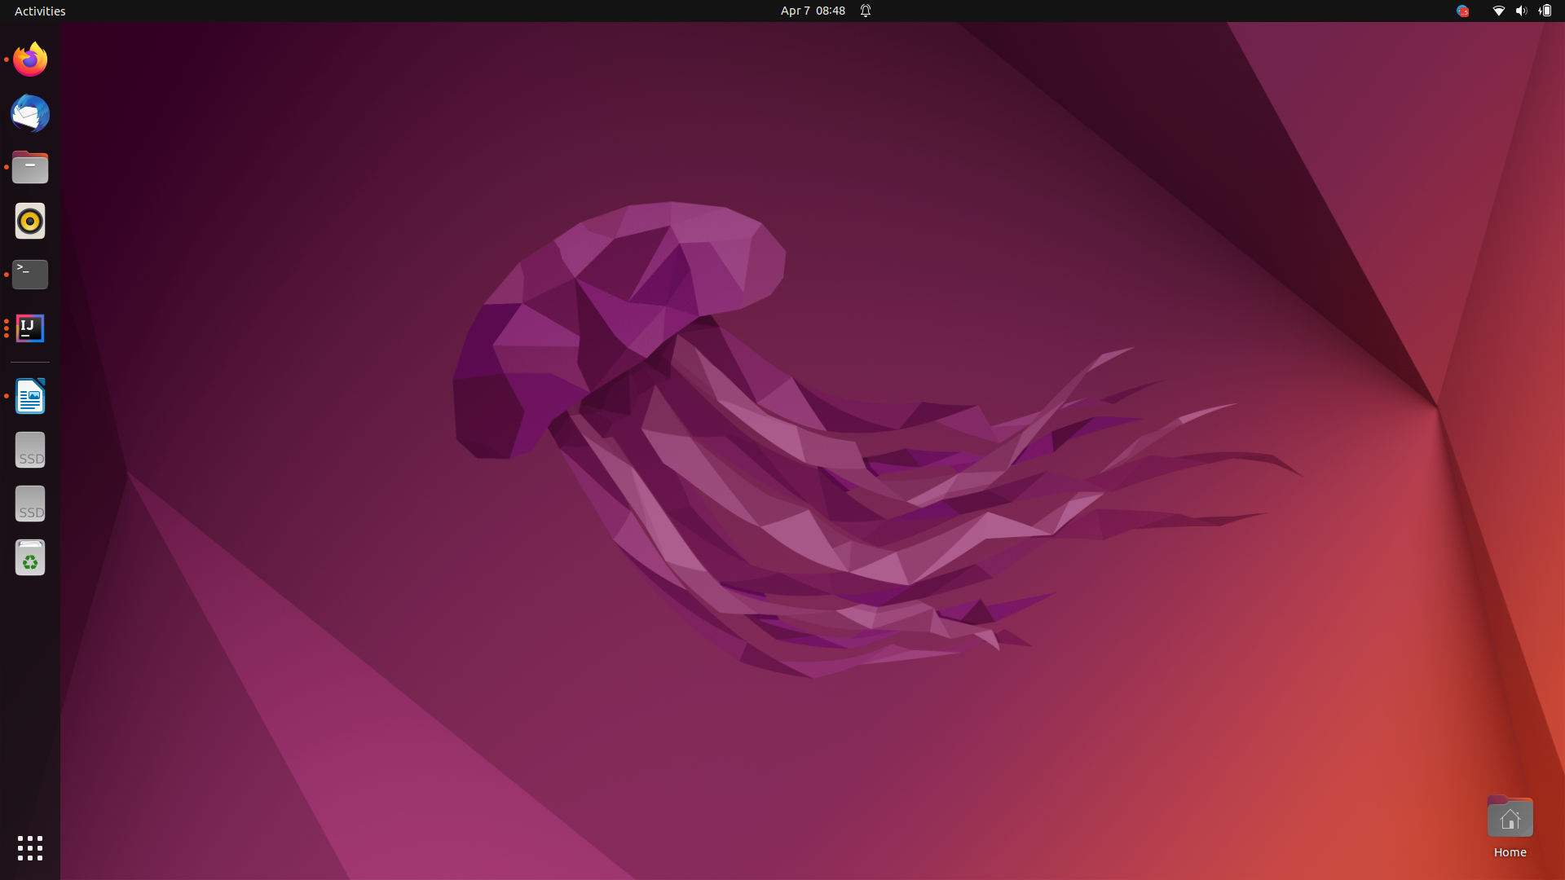

Here is the newly installed Linux Ubuntu 22.04